E Commerce Website

Create a conda environment

Conda create -p “env_name” python=3.10 -y

Activate the environment

Source activate ./”env_name”

Install the packages

Pip install -r requirements.txt

Create a .env file to keep our environment variables

Setup.py file to install our local packages

Create a notebook folder and create a notebook file inside the folder

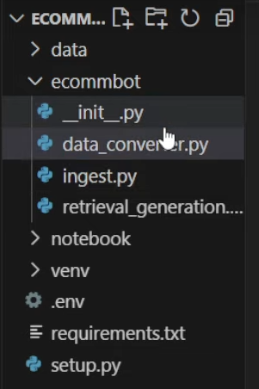

Create another file called ‘app.py’

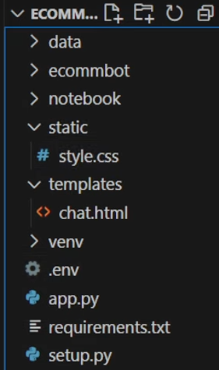

Requirements.txt

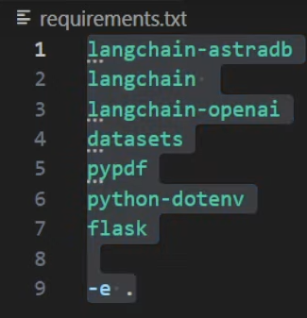

Select the environment that you have created

And do install the kernel inside the notebook file

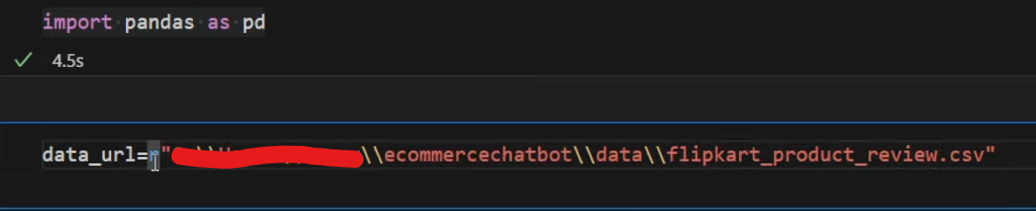



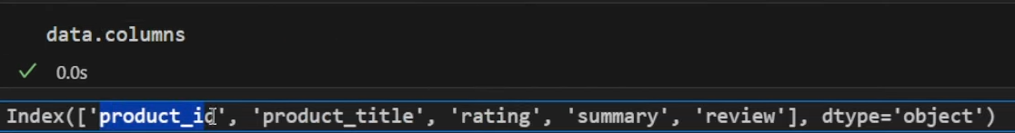

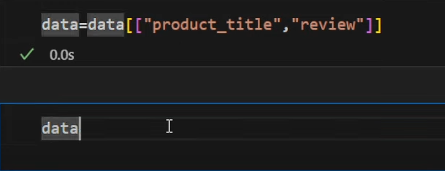

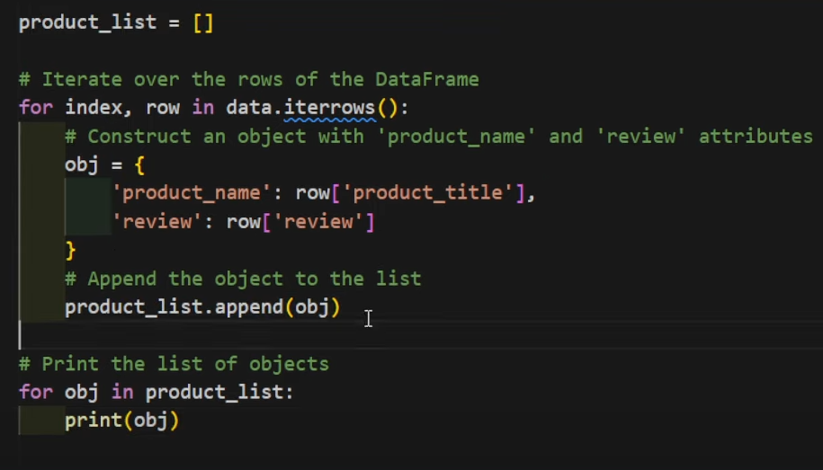

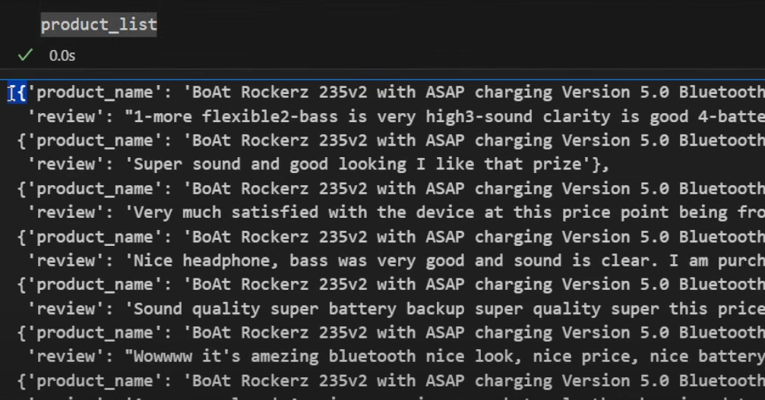

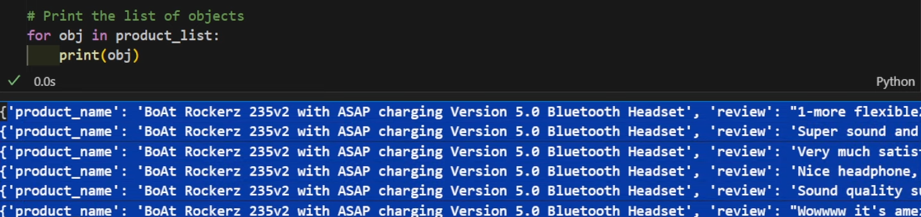



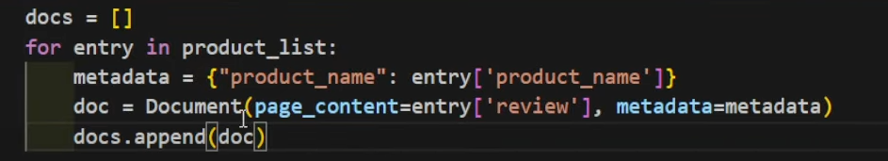

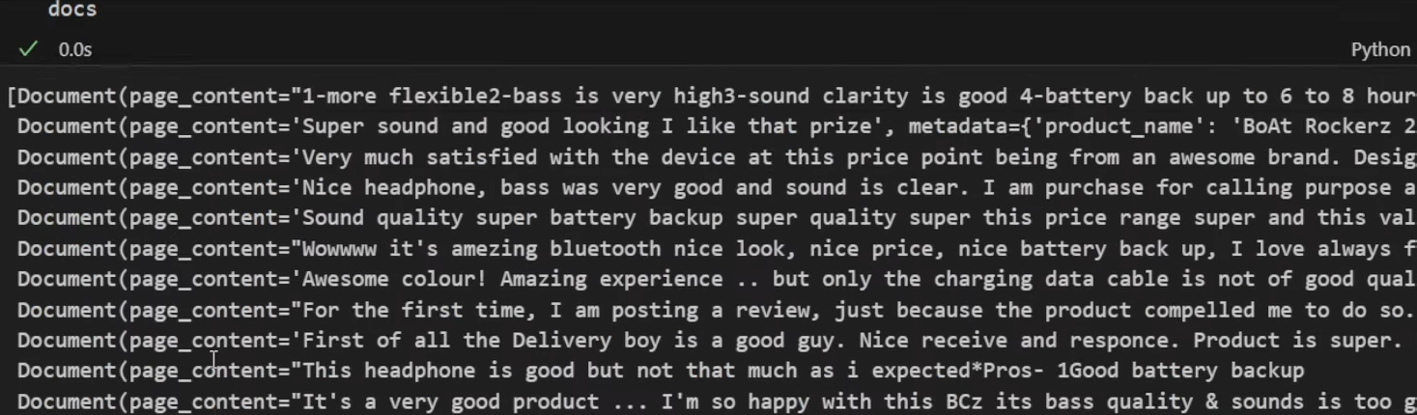

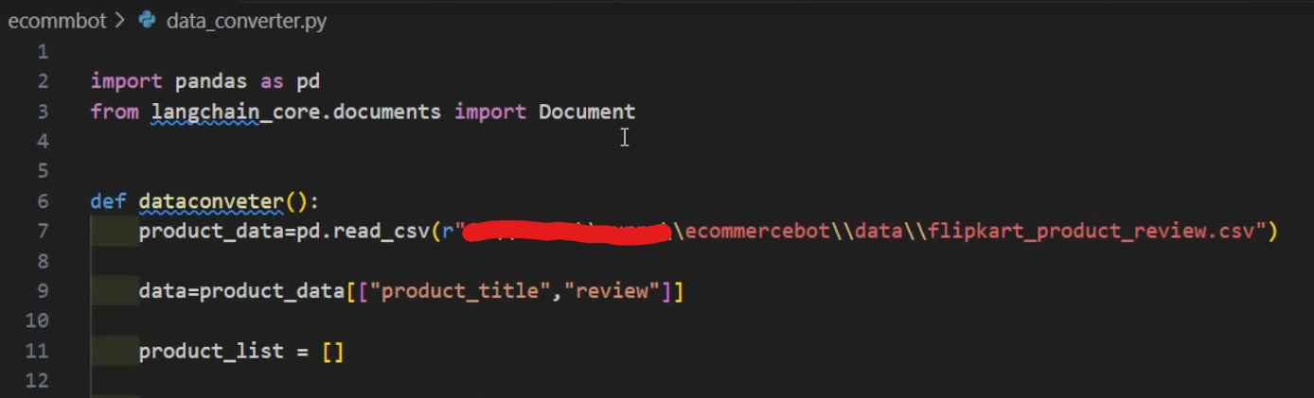

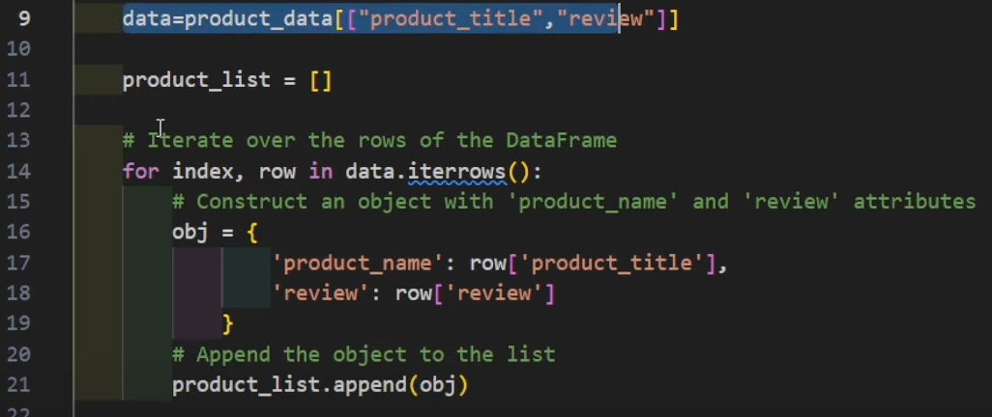

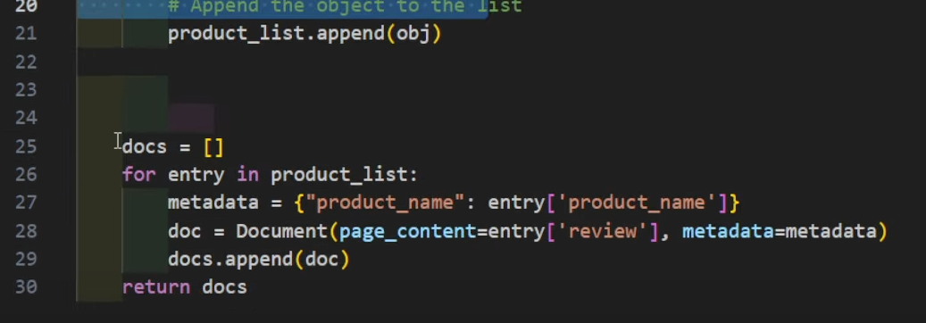

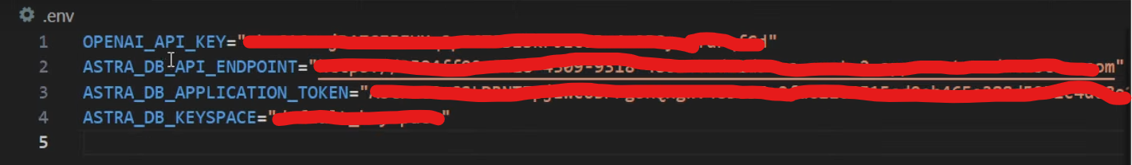

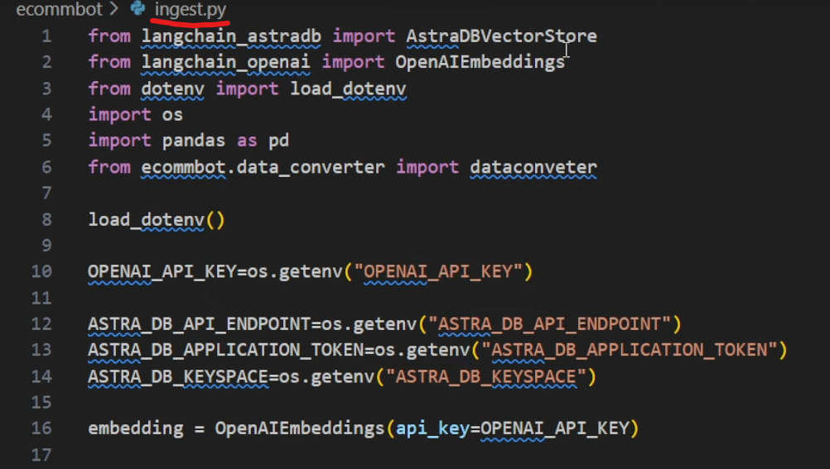

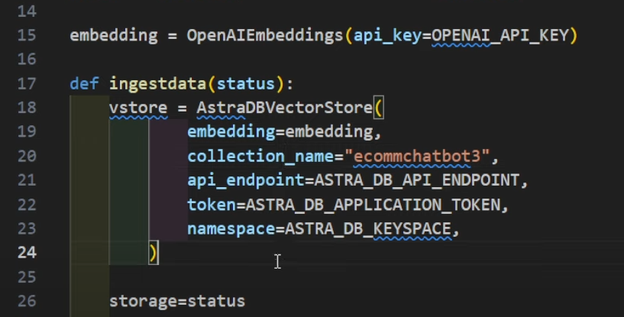

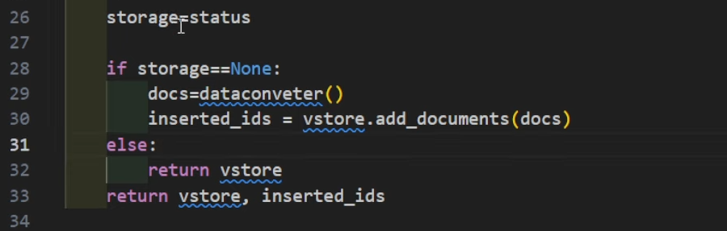

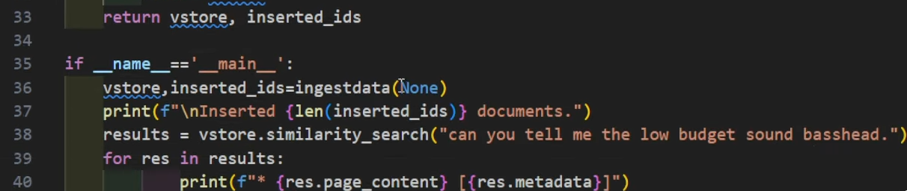

Now run the file ingest.py, then it stores the data inside the database

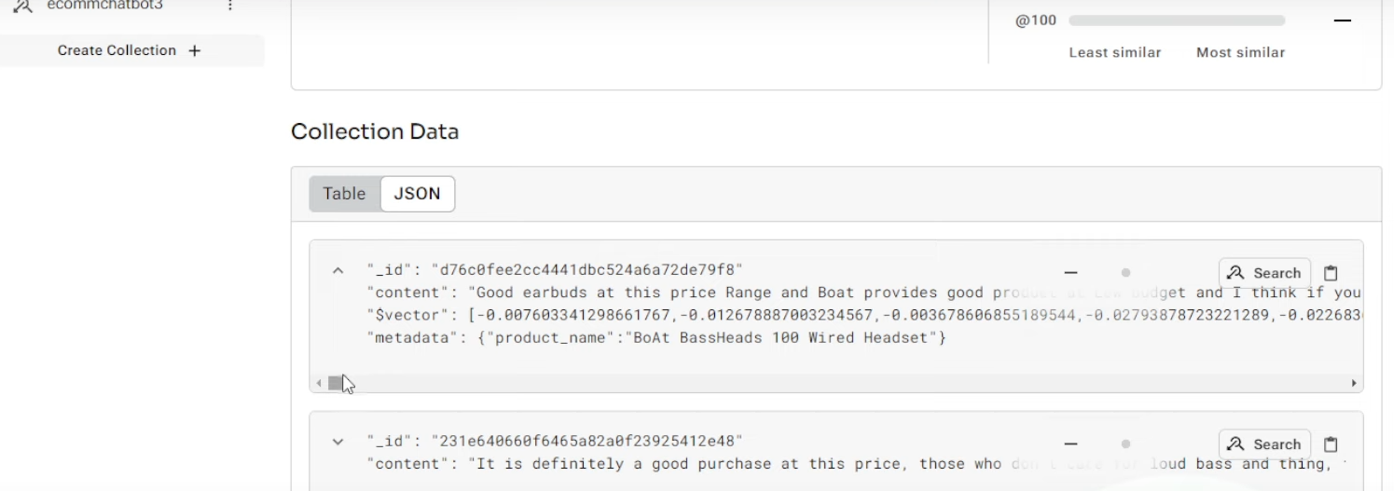

Now build the retrieval part

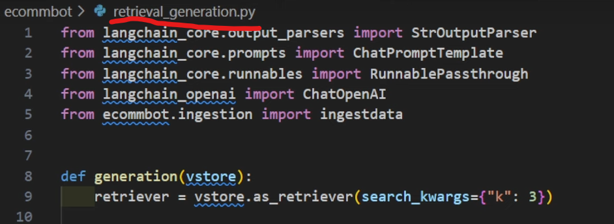

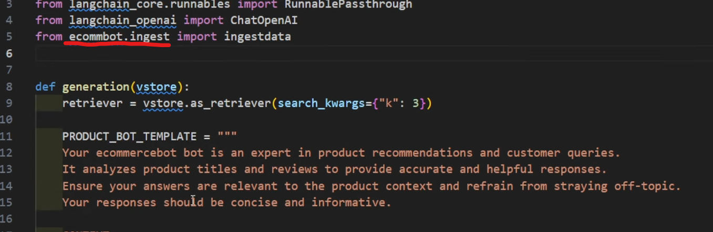

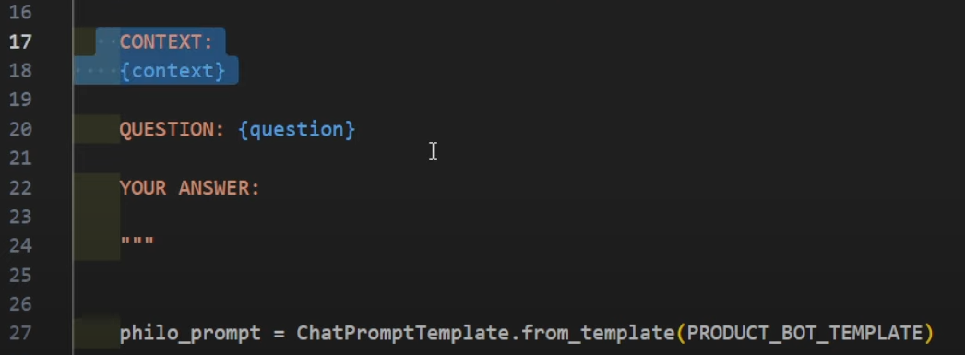

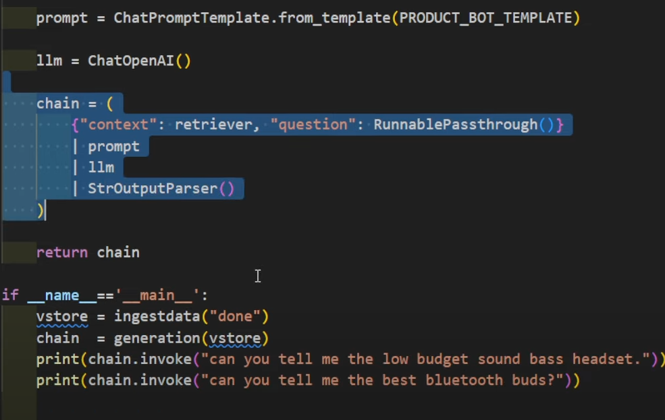

Now run the retrieval_generation.py file

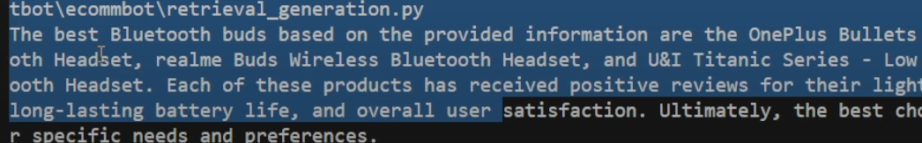

Lets create our web application (app.py file )

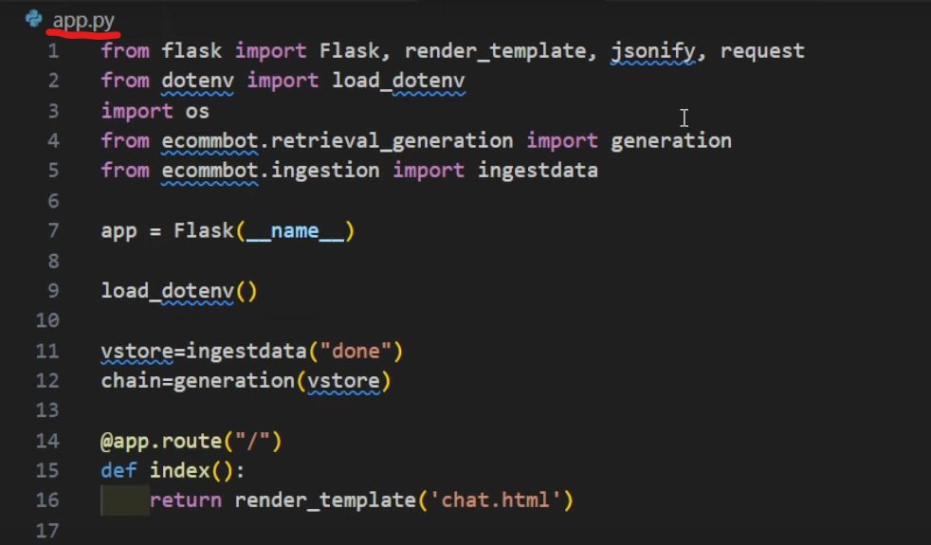

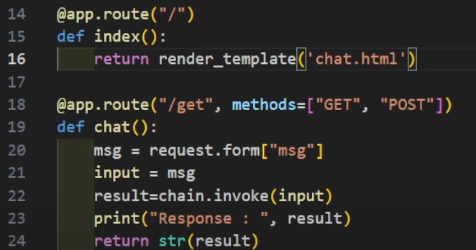

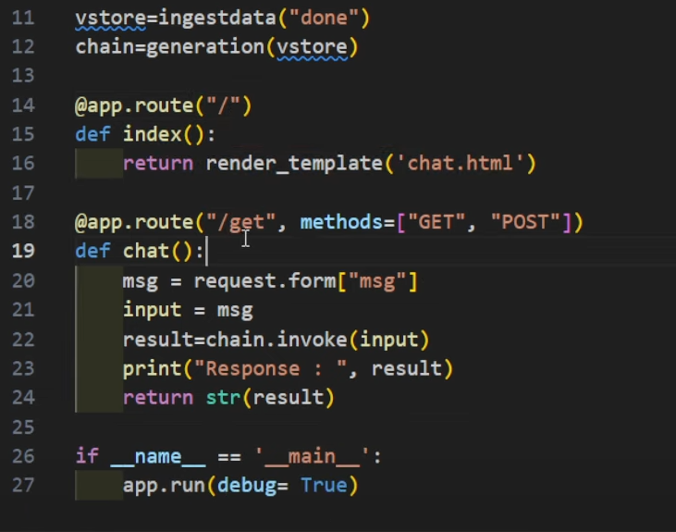

Index.html and style.css

Now run the app.py file

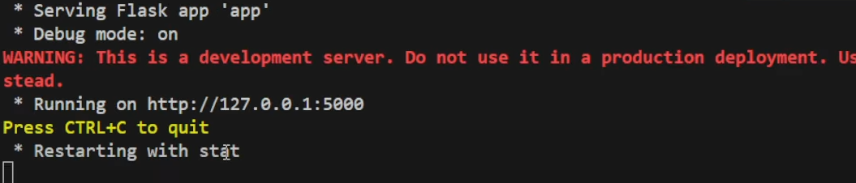

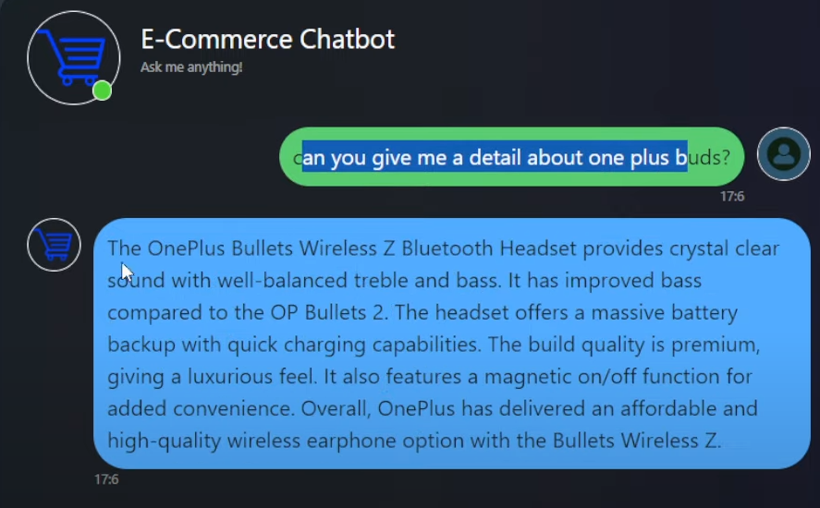

Deployment

Steps to follow

Login in to your AWS account, setup the EC2 instance then we need to configure it

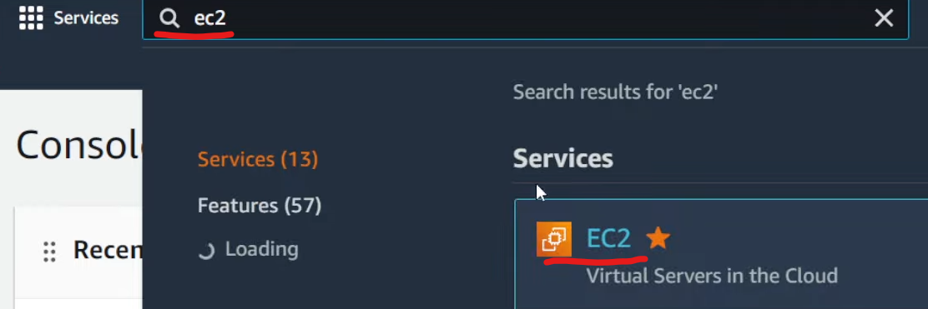

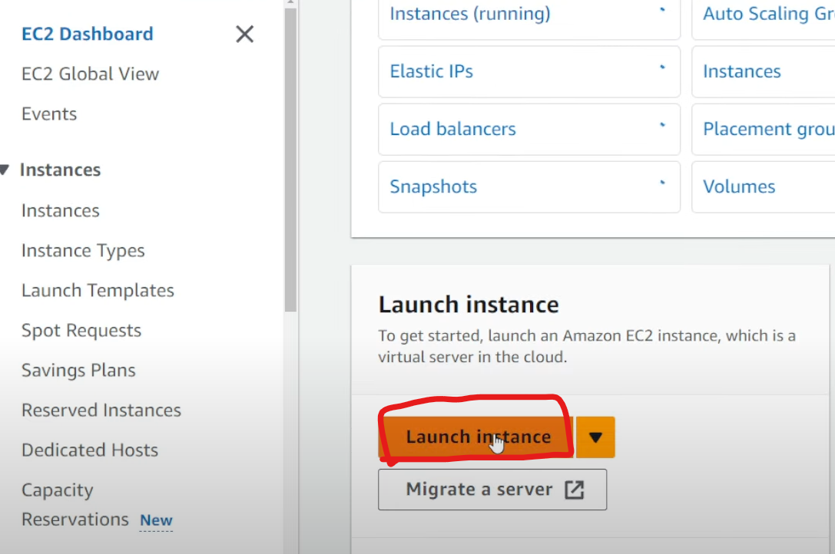

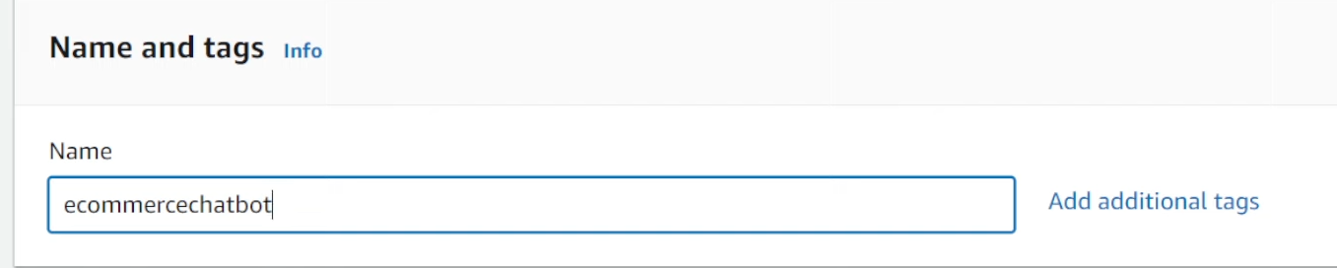

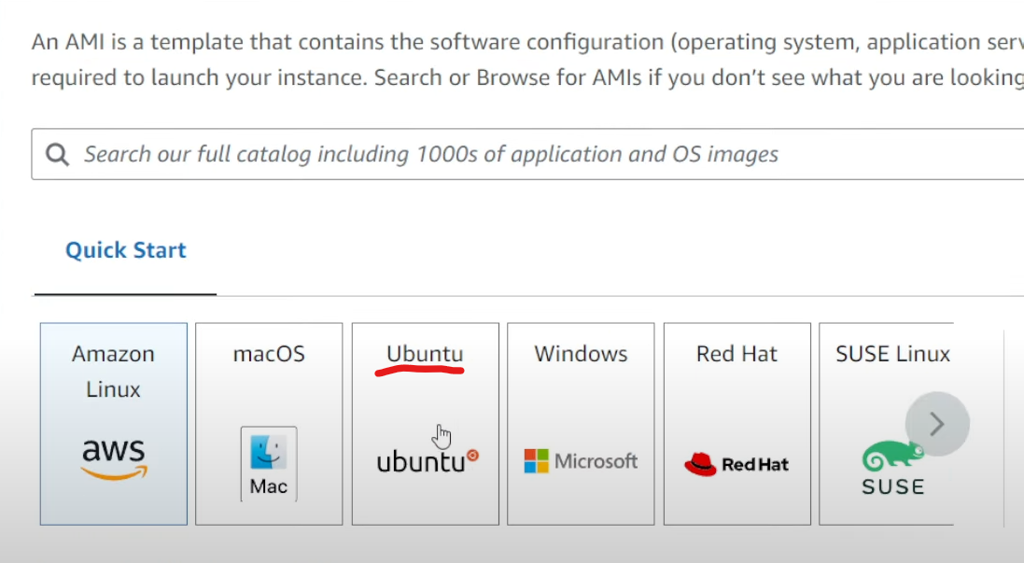

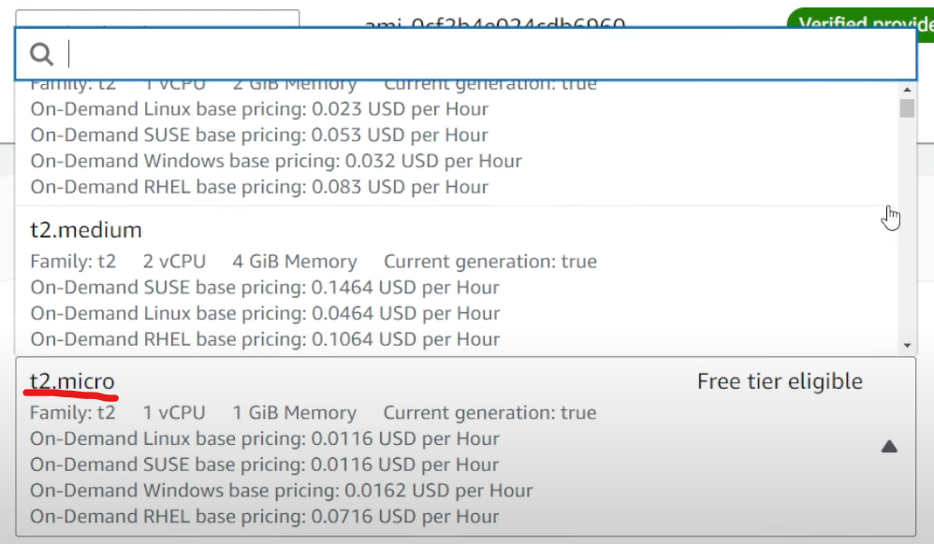

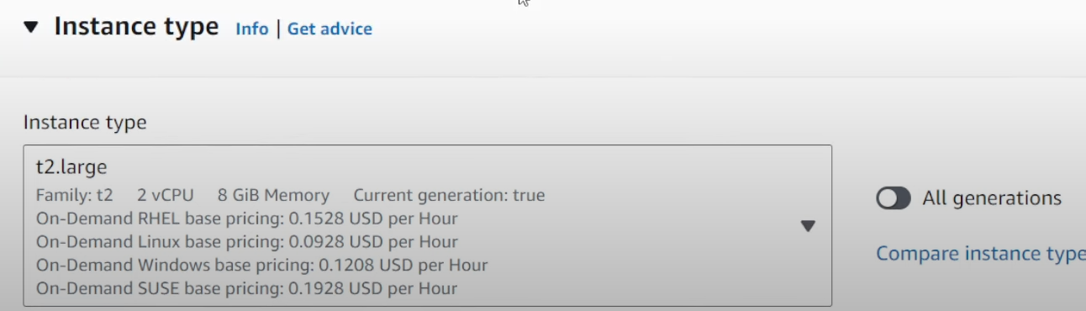

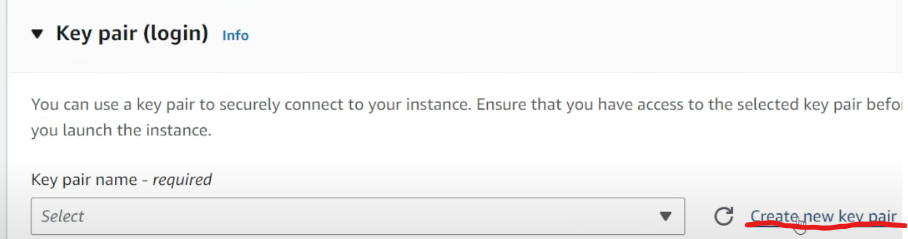

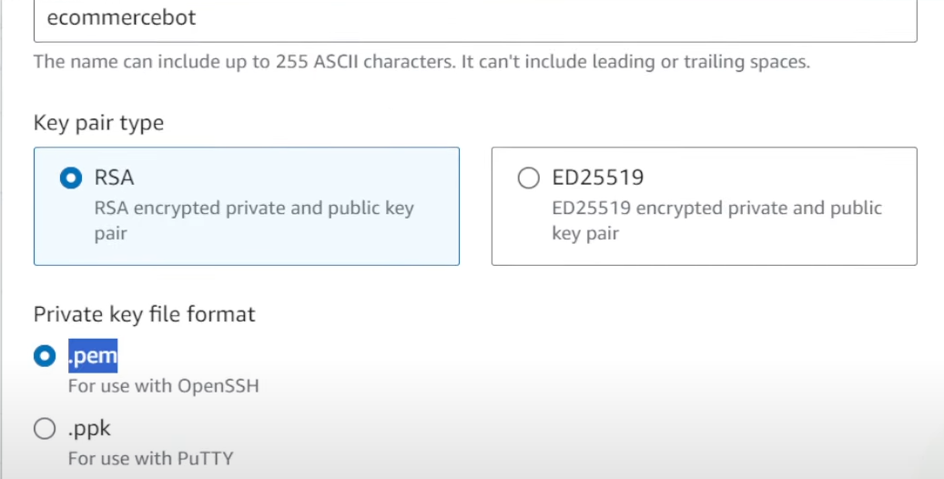

Then click create key pair and keep it inside in your system

Network settings

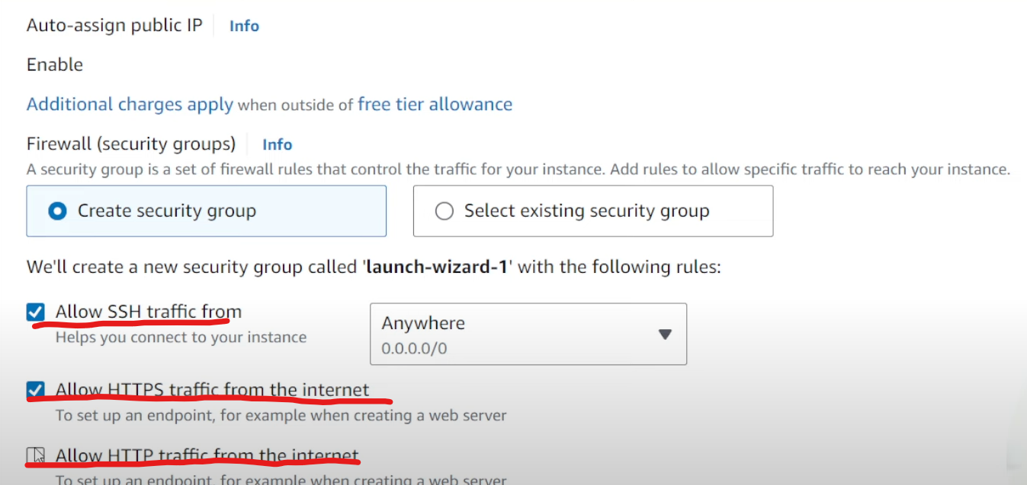

Configure storage

Change the storage based on your need.

Then click finally “launch instance” button

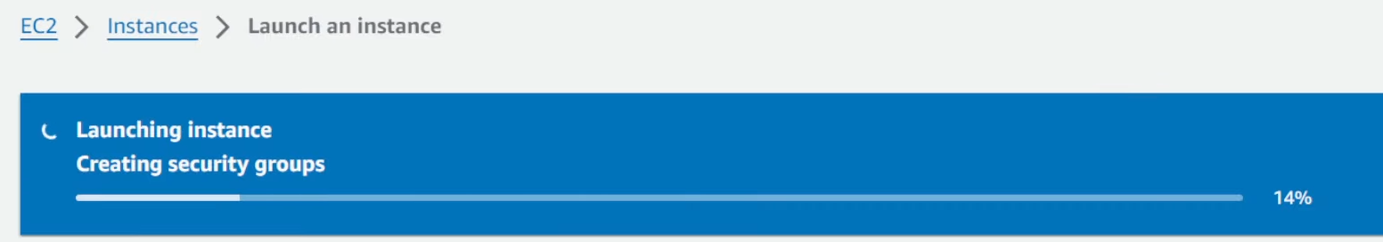

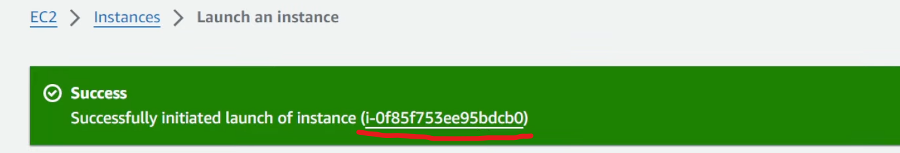

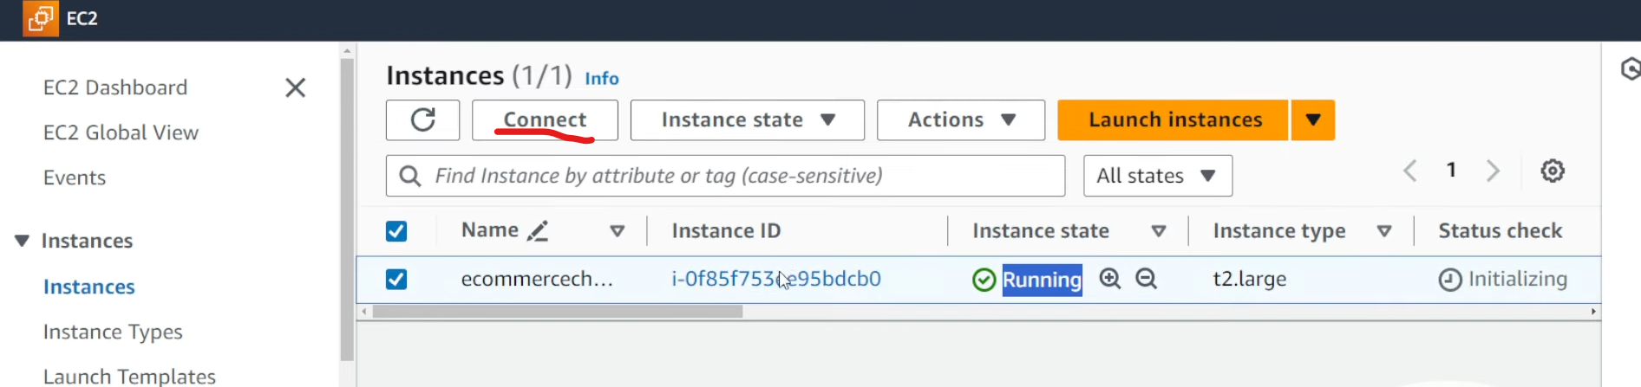

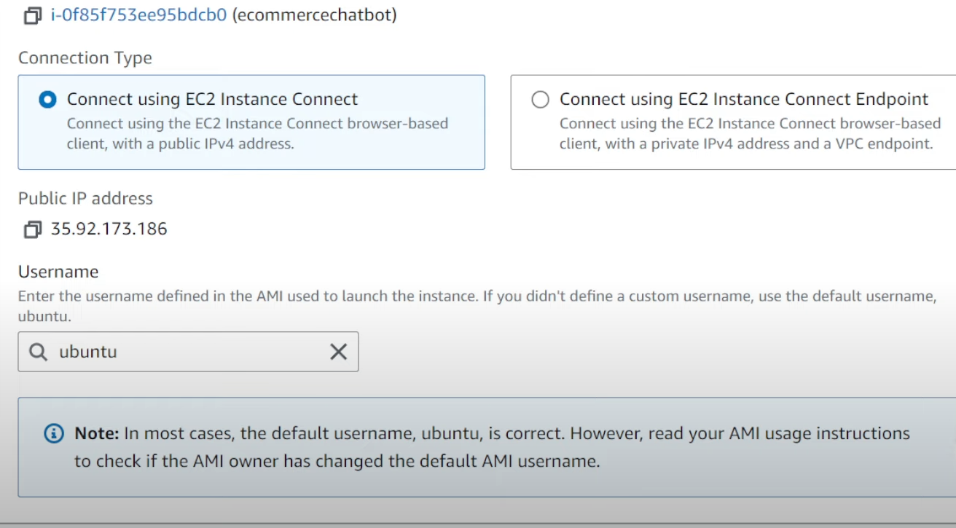

Click connect

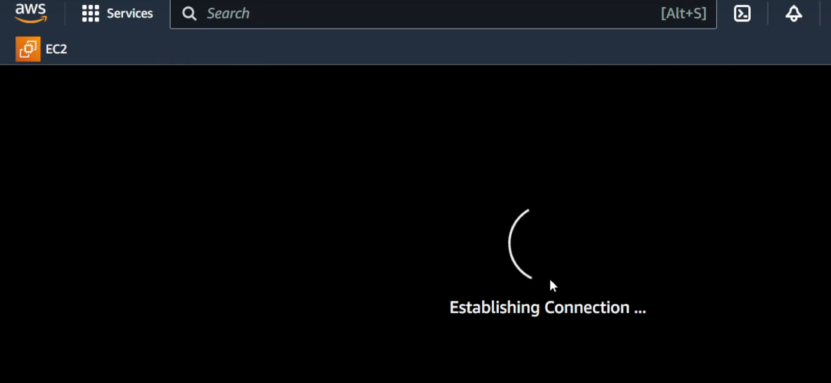

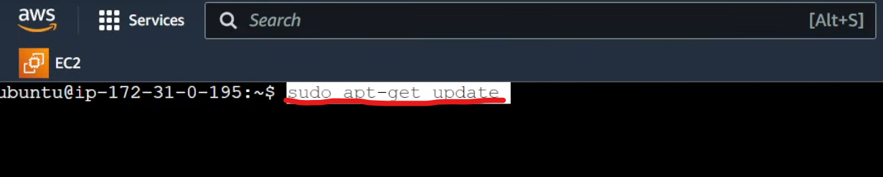





Do some changes in the dataconverter.py file

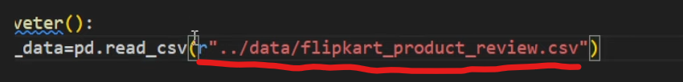

Push the code to git

Command : git init

Git add .

Git commit -m “first commit”

After we push the code in the repository we need to clone the repo in our EC2 instance.



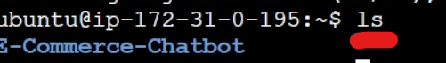



We don’t have .env file. So now we need to create the env file



Open the file (.env) using vi



Press insert

Copy paste the required secrets keys and endpoints

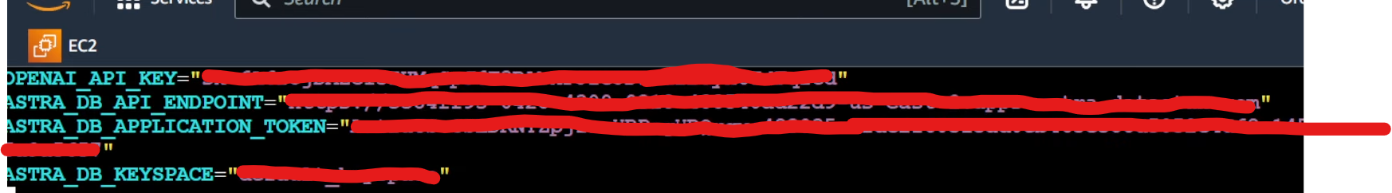

Press esc and then press :wq

Cat .env the you will see the secret keys and others



Once done then we need to install the requirements



If get any issues regarding the environment the try the below command



Finally run the application



Or python3 app.py

How to access the application

Click instances

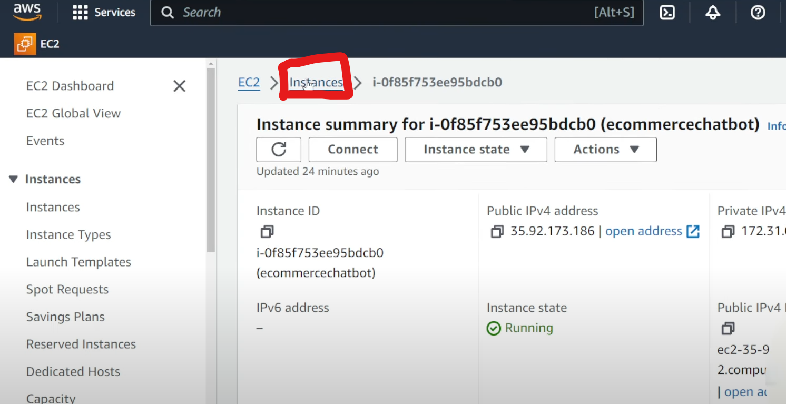

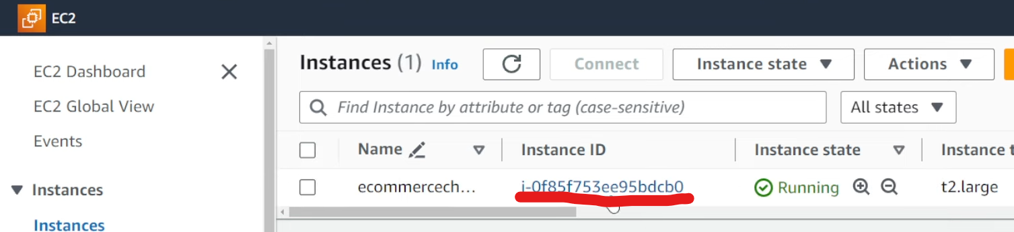

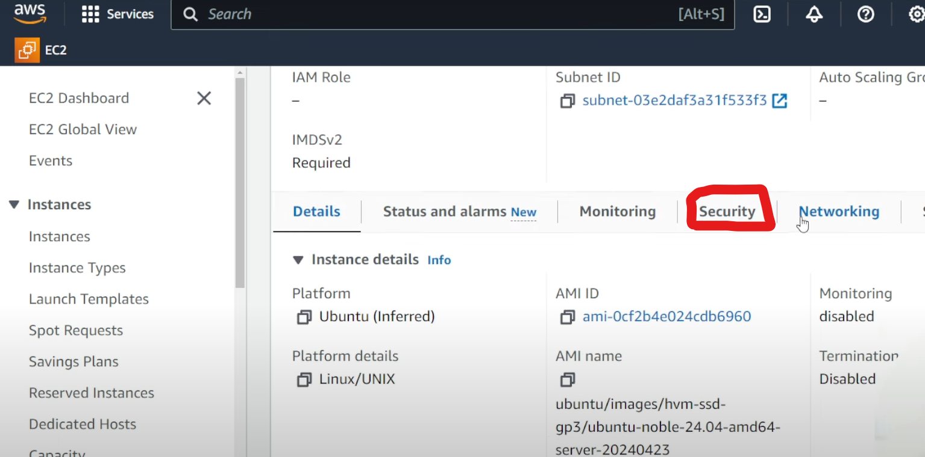

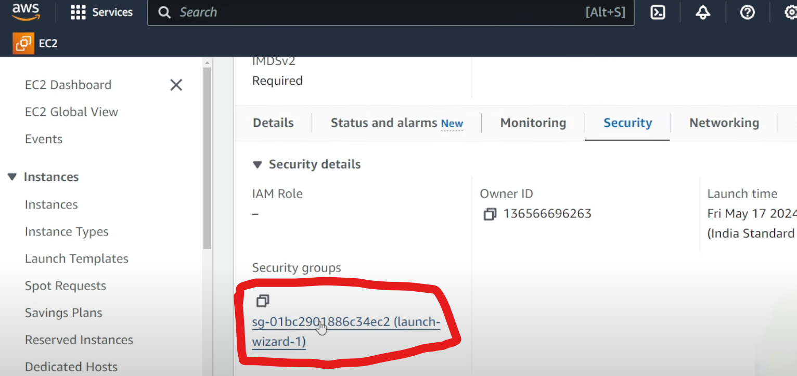

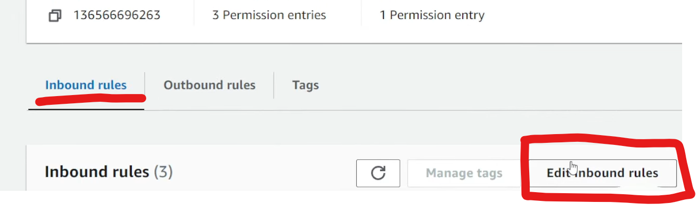

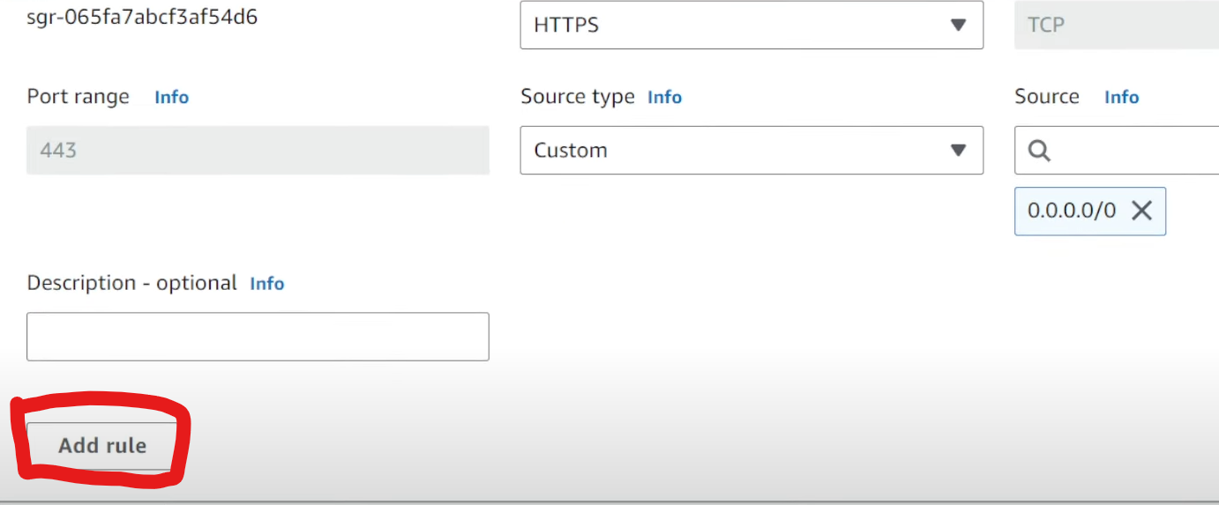

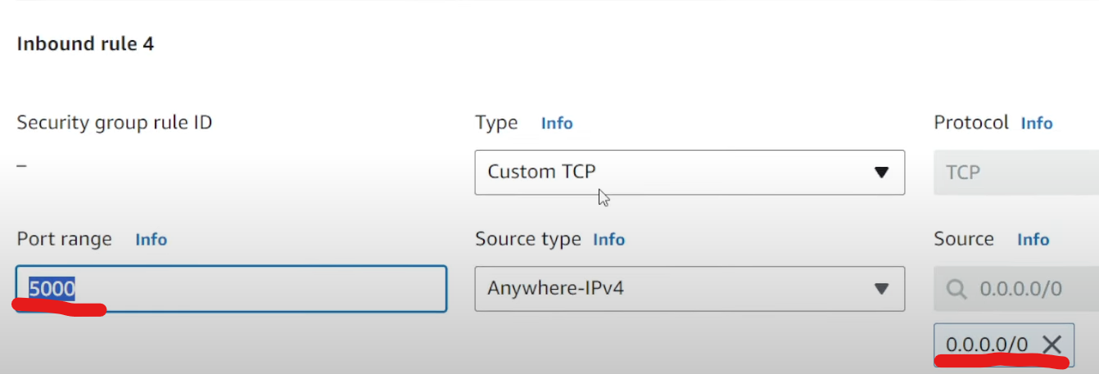

Then click save

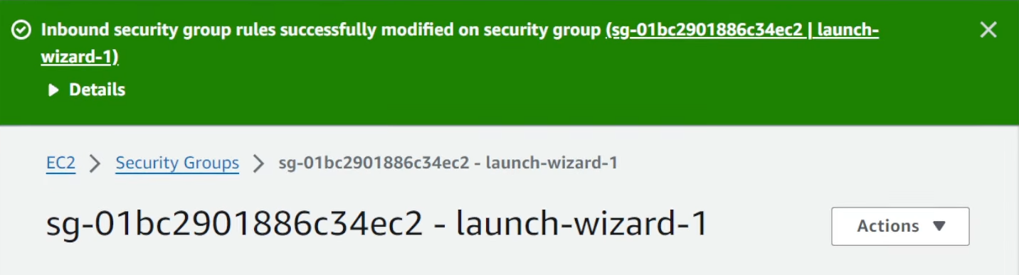

Go back to our instance

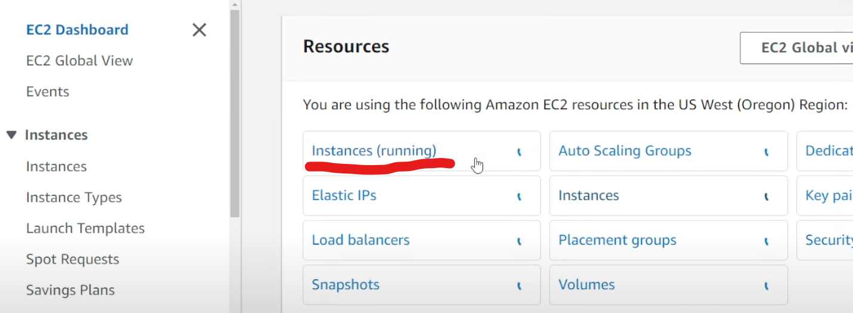

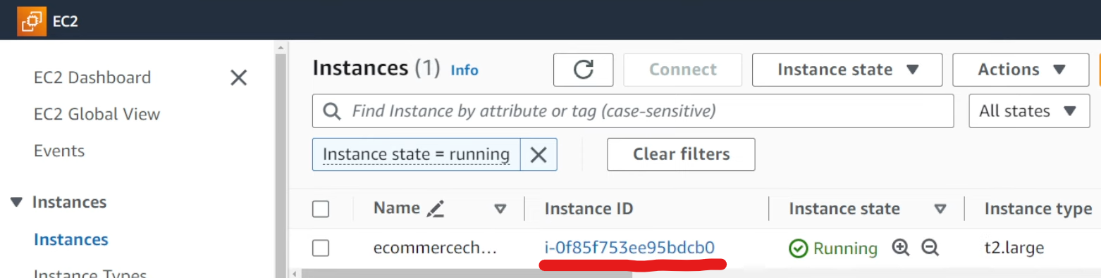

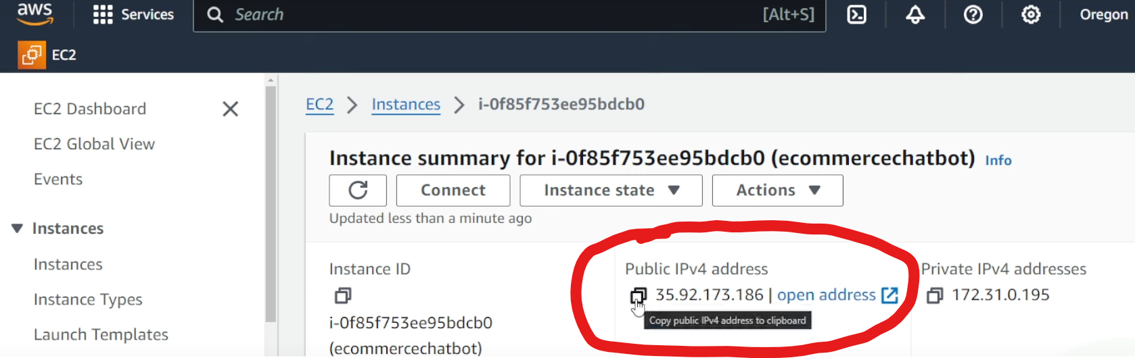

Open the browser with new tab and paste the ip address 

If it is not running then you need to do some modification in app.py

Cat app.py

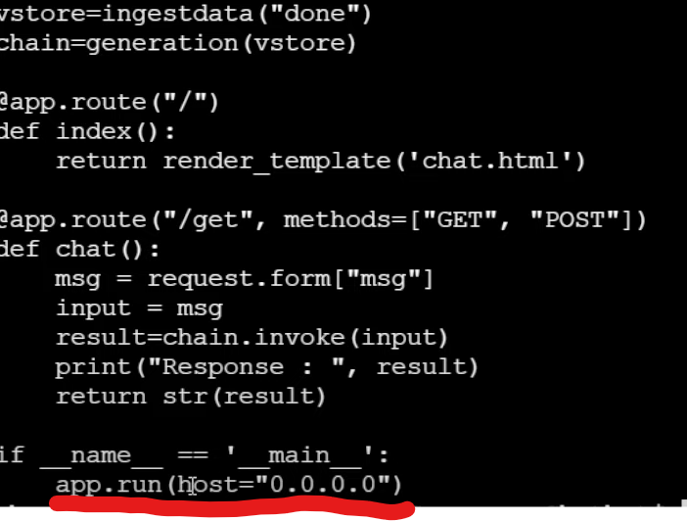

Now run python3 app.py

Copy and paste the ipaddress and mention the portnumber

